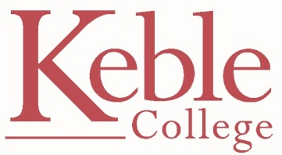
TALBOT SOCIETY PROPOSAL/INFO FOR JCR MEMBERS

Once a member of Keble, always a member of Keble!
When you finish your studies we hope that you’ll stay in touch. During your time here, former students, aka Old Members (yes, sorry about that!) have been contributing to the well-being of Keble and its students in numerous ways. You may have noticed OMs attending events and lectures in College, running workshops, master-classes and seminars throughout the year (during Arts Week in particular), coming back to play ghosts football/rugby, offering careers advice etc. OMs also sit on several College committees which advise Governing Body and 40% of OMs have made a financial contribution to support Keble and Keble students.

Why support Keble?
Because to offer a fully-fledged, often tutorial-based, ‘Oxford’ education requires resources beyond our current capability. It is an expensive way to teach but one which we believe is worth preserving. Even with government funding and tuition fees there is a shortfall of over £2,000 per student per year. We make up for this shortfall with income from our thriving conference business and with charitable donations from alumni and friends. The Talbot Fund encourages all OMs to make affordable regular donations to support the core work and extra-curricular life of the College.

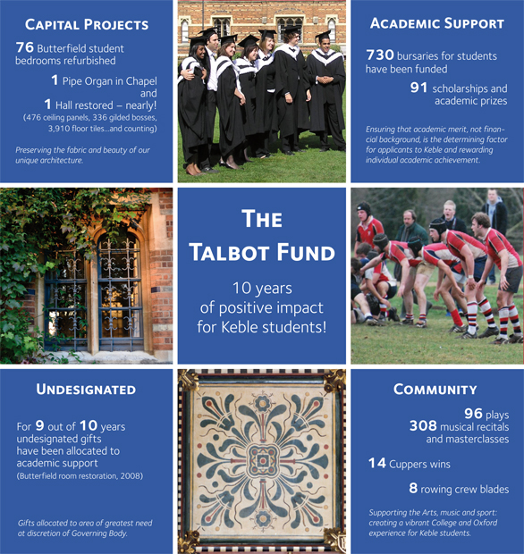
What has the Talbot Fund done for me?

Gifts to the Talbot Fund have enhanced our ability to fund bursaries, scholarships and academic prizes for students. They have also enabled some wonderful restoration work to take place in the Hall, Chapel and student rooms as well as providing resources for music, sports and the arts, all of which enhances the extra-curricular life of the College. All Keble students have benefited in some way from the generosity of the generations that have gone before.

Why me? I’m broke!
Participation is the key to the success of the Talbot Fund which is one of the top performing annual funds across Oxford colleges. We hope that young alumni will wish to do their bit too. Developing a culture of giving from young alumni really will strengthen the College for the future. For example, if every undergraduate leaver of 2013 were to make a gift of £20 (from their ‘Caution Money’ refund of £150) this would generate £2,600 collectively – enough to fund 3 ‘top up’ bursaries for students with greatest financial need next year.

The proposal to all JCR Leavers to join the Talbot Society*
- Please make a gift of £20 from your ‘Caution Money’ (ie £150 deposit paid on entering Keble to be refunded/credited to your battels account at the end of your final term)
- Support the area of College that you care about most and want to maintain (eg academic bursaries, music, sport, the Butterfield buildings)

Benefits to JCR Leavers
- Do something amazing for the students who are still here
- Be one of the pioneers of the new Talbot Society whereby most leavers give something back each year to help the next generation
- Receive a ‘Keble’ brick – your reminder that you are part of Keble, that we’d like you to keep in touch and let us know your news from time to time

Benefits to Keble and Keble students
- £20 cash income added to existing support for a particular area at donor’s request
- a new generation of alumni who wish to stay connected and are supportive of College and the education we strive to provide for all students
- leavers of 2013 will set an inspirational example to existing (and future) alumni; if we all pull together then maximum participation can be achieved providing more funding and better resources for future students

What do I do?
Please vote to support the JCR motion to join to the Talbot Society with a £20 deduction from your ‘Caution Money’ refund and we’ll do the rest. We will contact you, in the term you are due to leave, with information about joining the Talbot Society and how to opt-out. Shortly before you leave, you will receive your Keble ‘brick’ with our thanks and a request to let us know the area of College to which you’d like to allocate your gift.

* Talbot Society Membership
By way of recognition and thanks, members will be listed in the annual Keble Review unless otherwise directed.
Membership Type | Who | Gift | Recognition
Honorary | Leavers | £20 | Keble ‘brick’  (that’s a foam brick!)
Red | Young Alumni  (0-5 yrs) | Small Regular gift  (£20 per year) | Keble ‘brick’  + red Keble pin
Blue | Alumni (5+ years) | Regular/Annual gift | blue Keble pin
Dinosaur | All Alumni | Continuous regular gift for 10+ yrs | gold Keble/Dinosaur pin

Mrs Camilla Matterson
Deputy Director of Development
Alumni & Development Office

